**Phase 1: Project Definition**

This Project mainly aims to find out the trend of the vaccinations around the world for the prevention of the Covid 19 pandemic and how much has been achieved so far.

**Design Thinking:**

**1.Data Collection**

The COVID 19 pandemic caused due to the Corona virus devastated the world by causing several fatalities around the world. This virus originated in Wuhan, China in 2019 and was later spread throughout the world due to human contact in one way or the other. The disease showed symptoms as basic as mild fever and cold but also caused life threatening symptoms like breathing problems caused by damage to the lungs. As this virus was new to the world and there was no vaccine or cure to it at the initial period there were several deaths around the world. The countries around the world were forced to shut themselves to others in order to avoid the further spread of the virus and people were stuck inside their houses and faced many issues with their finances, mental health etc., and felt like animals in a cage. An effort was made to find a cure or vaccine by several health organizations to bring a stop to this pandemic.

In later stages of 2020 several experimental vaccines were developed and was administered to humans. The efforts were successful as the vaccines were helpful in reducing the affects the virus and even if people were infected, they were not in any life threating situation and escaped the illness having only minor symptoms.

Many countries later developed their own vaccines and also helped other countries without the resources by providing them with vaccines developed.

**2. Visualization**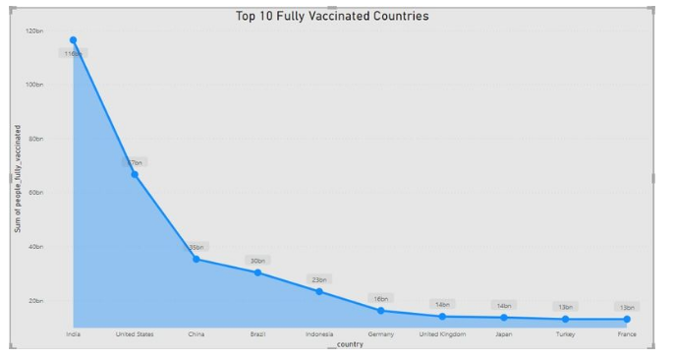

**Insights –**

* Here we analyzed the top 10 fully vaccinated countries in which India tops the list which indicates that people in the country where showing lots of interests to get vaccinated.
* And also analyzed top 5 vaccinated countries here also India tops the list.
* And then analyzed top 5 daily vaccinating countries and here China tops the list.
* And also we analyse the sum of daily vaccinating details, fully vaccinating and vaccinating people details.
* And our year wise analyse shows that 2021 was the peak year for every vaccination details.

**Recommendations –**

* We should collect day to day reports and we should update our records daily to get more accurate details.
* So that we can move forward with more vaccination to the right country which needs the most.

**Conclusions –**

In this dataset we came to know that the vaccination process in every country was going in good pace that indicates we can have control of this disease very soon all over the world.

